**Business Requirements Document**

for

**Robi Super Consumer Application**

Prepared by:

**Walletmix Limited**

24.03.2021

Contents

Business Requirements Document 1

Business Objectives 3

Project Scope 4

User Definition 4

Device Platform Specification 4

Web Platform Specification 4

Functional Requirement 5

Delivery Schedule 12

Assumptions 12

Risks 12

# Business Objectives

The intended digital platform will enable any registered Robi Subscriber to sell, promote or refer any kinds of Robi products to any existing or potential subscriber. The solution will be integrated with Robi eco systems to enable services fulfillment to the customers immediately after the sales request is placed and instantly provide commission/discount/bonus to the seller and purchaser. Multiple product line can be configured in the platform to offer to the users.

Below features will be available in the digital platform for Robi/ Airtel customers to achieve the above objectives.

1. Customer selling EL to another Customer (any Robi/AT Customer)
2. Customer selling any pack (minute/Data/SMS/Combo) to another Customer
3. Customer referring another Customer by using unique referral code
4. Customer creating/registering new single app user (My Robi for My Robi; My AT for My AT) by using his/her Customer platform
5. Customer referring another Customer for SIM purchase (GA reference)
6. Customer referring another Customer for MNP (MNP reference)
7. Customer referring another Customer for 4G SIM replacement (USIM Swap reference)
8. Customer selling VAS/digital services products/Binge (or purchasing for another Customer) to another Customer by using Customer platform
9. Customer selling any Robi shop products (or purchasing for another Customer) to another Customer by using Customer platform
10. Customer selling any IOT products (or purchasing for another Customer) to another Customer by using Customer platform

All the above features will be developed considering **Multiple Distributor Module** and **Multiple Payment Gateway Module**.

Walletmix has the track record in accomplishing projects of such complexity and magnitude and have provided case studies proving its capabilities in accomplishing such projects.

Walletmix has the right mix of domain expertise, company size and skills in cutting edge technologies, mobile and rich web to provide flexibility, time-effectiveness and cost-effectiveness to deliver this project.

# Project Scope

This project will enable any registered Robi/Airteluser will be able to sell, promote, or refer any Robi product to any current or potential customer via the intended digital portal.The solution will be integrated with Robi eco-systems to allow immediate service fulfillment to customers after a sales request is placed, as well as instant commission/discount/bonus payment to the seller and purchaser.

## User Definition

Following type of users will have access to the platform:

|  |  |
| --- | --- |
| **User Type** | **Platform** |
| Admin | Web |
| Customer | Android/ iOS |

## Device Platform Specification

|  |  |
| --- | --- |
| **Platform** | **Version** |
| Android (Smart phones and Tablets) | 4.4 to latest |
| iOS (Smart phones and Tablets) | 10 to latest |

## Web Platform Specification

|  |  |
| --- | --- |
| **Platform** | **Version** |
| **Google Chrome** | Latest browser version |
| **Mozilla** | Latest browser version |
| **Internet Explorer 11** | Supported up to August 2021 |
| **Microsoft Edge** | Latest browser version |
| **Safari** | Latest browser version |

# Functional Requirement

# 

* Admin will visit an URL (for example: [www.example.com/admin](http://www.example.com/admin)) and login in the system using his/her User name and password. If the credentials are accurate, then the login procedure will be confirmed from the system
  + A default User name will be provided by us to the admin. Admin can create multiple required user names from the system
* The admin can update his/her basic information from the profile option such as name, contact number, etc.
* The admin can change and create new password to secure the account from any unwanted occurrence
  + To set a new password, the admin has to use at least 8 characters
  + The password should contain at least three of the four criteria from the following options: Minimum one small letter, minimum one capital letter, minimum one numerical digit, or minimum one special character
* The admin will be able to create role and can also give a name to the role. From the permission list, the admin can select the required permissions for the role
* The admin will be able to change the basic information, i.e. name, contact number and other details of the users (the users that the admin created) and update the information
* The admin can view thana, district, region mapping from system settings option
* From the logout option, admin will be able to log out from the system and he/she will be taken back to the login page
* If the admin forgot his/her password, upon the admin’s request, an OTP will be sent. After verifying OTP, the admin will be able to set new password

# BRS-Admin-2.png

* The admin will be able to access content management option in order to manage promotional contents and publish those contents in Robi SCS platform
* The admin can onboard a distributor by filling out the basic information, account information, configuring MSISDN, Payment Gateway and assigning region to the distributor
* The admin can update any distributor’s data from distributor management. Also, any distributor’s password can be reset and new password can be created from distributor management
* The admin can update any SC’s data from SC management. Also, any SC’s password can be reset and new password can be created from SC management
* From the report management option, admin can generate distributor selling report, SC selling report, Distributor SC’s report and SC commission redeem report

# BRS-Distributor.png

* Distributor will visit an URL (for example: [www.example.com/admin](http://www.example.com/admin)) and login in the system using his/her User name and password. If the credentials are accurate, then the login procedure will be confirmed from the system
* The distributor can update his/her basic information from the profile option such as name, contact number, etc.
* The distributor can change and create new password to secure the account from any unwanted occurrence
  + To set a new password, the distributor has to use at least 8 characters
  + The password should contain at least three of the four criteria from the following options: Minimum one small letter, minimum one capital letter, minimum one numerical digit, or minimum one special character
* The distributor will be able to check balance of both Robi and Airtel by selecting the brand name and providing the PIN
* After the distributor adds fund, EL will be transferred from Operator’s (Robi or Airtel) Master SIM to Retail SIM. Amount and PIN has to be provided to complete the transfer
* From the report management option, distributor can generate SC lifting report, SC selling report, SC commission report and SC commission redeem report
* From the logout option, distributor will be able to log out from the system and he/she will be taken back to the login page

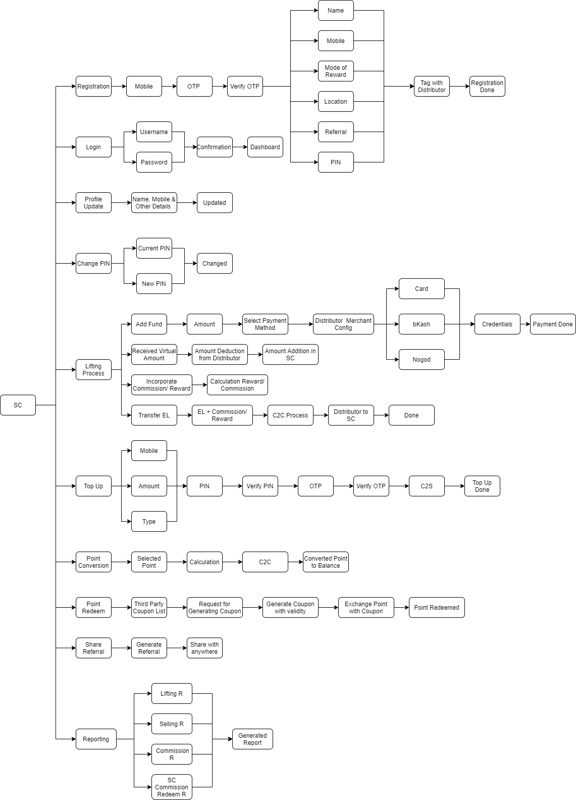

* From Robi Super Consumer App, SC will be able to register by entering their mobile number. After some time, the SC will receive OTP and he/she has to verify the OTP. After successful verification, SC has to provide his/her name, mode of reward, PIN etc. information. Upon receiving information, the SC will be tagged with a distributor and the registration process will be done
* The SC can login in the app using his/her User name and password. If the credentials are accurate, then the login procedure will be confirmed and SC will be taken to the app homepage
* The SC can update his/her basic information from the profile option such as name, contact number, etc.
* The SC will be able to change his/her PIN from the app by entering the current and new PIN
* The SC can add fund by selecting the payment method, followed by sending the amount to distributor’s account through Card, bKash or Nagad and confirming the credentials. SC will receive virtual amount and amount will be deducted from Distributor and added to SC. The commission/reward will be incorporated by calculating the actual commission/reward. Through C2C Process, EL+ Commission/Reward will be send to SC from Distributor
* SC can provide top-up by entering the mobile number, amount, operator type and entering the PIN. An OTP will be sent and after verifying the OTP the process will be done
* SC can convert point by selecting the point amount and after calculation, the point will be converted to balance
* SC can redeem point through third party coupon list. Point can be exchanged with the available coupons and thus the points can be redeemed
* SC can share referral code with anyone so that others can sign up too
* From the report management option, SC can generate lifting report, selling report, commission report and commission redeem report

# Delivery Schedule

Project SCS with Android, iOS Mobile and Web Application will be delivered in two phases. Phase one will be complete for deployment 138 calendar days after PO issue and Phase 2 will be completed 98 calendar days after Phase-1 completion. Phase wise delivery will include Solution Development, UAT and Bug Fixing. 5 days for Go Live. 3 months Post Go-live intensive support. 7 days for FAC. However, throughout the overall system development Walletmix Limited has dependency on Robi Axiata. If there is any delay in correspondence or support from Robi Axiata, Walletmix Limited will not be liable to meet delivery deadline. An additional charge will be applicable if project time is crossed due to any delay in correspondence or required dependency support from Robi Axiata. See below estimated timeline.

|  |  |  |  |  |  |
| --- | --- | --- | --- | --- | --- |
| **Sl no.** | **Milestone** | **Software Life Cycle** | | **Start Date** | **Completion Date** |
| 1 | 1 | Requirement Analysis | | 1/3/2021 | 14/3/2021 |
| 2 | Design | | 15/3/2021 | 28/3/2021 |
| 3 | 2 | Development | Web | 15/3/2021 | 05/07/2021 |
| Android | 15/3/2021 | 05/07/2021 |
| iOS | 15/3/2021 | 05/07/2021 |
| 4 | Testing | | 06/07/2021 | 10/07/2021 |
| 5 | Deployment | | 11/07/2021 | 16/07/2021 |

# Assumptions

* No major shift in technology
* Training will be conducted internally
* The project scope will not change once the stakeholders sign off on the scope statement
* Project will follow team governance guidelines and requirements

# Risks

* Delay in earlier project phases jeopardizes ability to meet fixed date
* Added workload or time requirements because of new direction, policy or statute